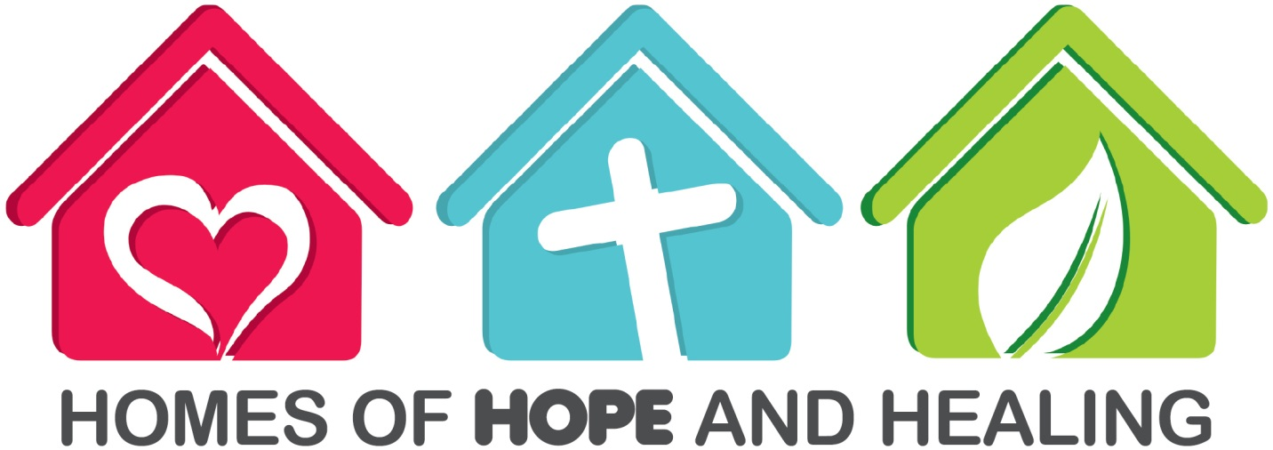
OUTREACH MINISTRY: “Homes of Hope and Healing”
The “Homes of Hope and Healing” program involves opening our homes to our neighbors for fellowship and learning. In these perplexing times, when hopelessness abounds, our homes can be places where neighbors, family, and friends gather in fellowship to share HOPE and HEALING for spiritual and emotional nurture. Here friendships among women are formed; hope, healing and encouragement are given; and needs are met.
Who needs hope?
- YOUR NEIGHBOR
- YOUR FRIEND
- THE SICK
- THE DISCOURAGED
- DYSFUNCTIONAL FAMILIES
- THOSE IN PAIN
- THE HOMELESS
- A CO-WORKER
- THE JOBLESS
- And many others
Women as well as men can engage in the work of hiding the truth where it can work out and be made manifest. They can take their place in the work at this crisis, and the Lord will work through them. If they are imbued with a sense of their duty, and labor under the influence of the Spirit of God, they will have just the self-possession required for this time. The Saviour will reflect upon these self-sacrificing women the light of His countenance, and this will give them a power that will exceed that of men. They can do in families a work that men cannot do, a work that reaches the inner life. They can come close to the hearts of those whom men cannot reach. Their work is needed. Discreet and humble women can do a good work in explaining the truth to the people in their homes. The Word of God thus explained will do its leavening work, and through its influence whole families will be converted.-- Testimonies, vol. 9, pp. 128, 129.

How can I create interest?
- In this ministry, we open our homes to women in our community. We work in small groups (between 1 and 15). The goal is to make lasting friendships for Jesus.
- Invite women to come to your home or other non-church location (if possible).
- You may want to offer a lunch or a light supper (optional).
- Share your personal testimony of what Jesus has done in your life.
- Invite them to participate in an eight-week “Homes of Hope and Healing” journey.
- Explain that this is an ongoing program with breaks every eight weeks. (The number of weeks is flexible. Keep it short to accommodate people’s schedules).

How do I organize the program?
- Choose one topic to focus on for eight weeks. Involve the group in choosing a topic so it fits their needs. Possible topics might be: health, spiritual nurturing, family, parenting, communication, etc.
- You may use DVDs, PowerPoint, printed lessons, or other media in your meetings.
- Invite speakers to present topics as needed. You do not have to lead out each time you meet.
- The presentation of the topic should be about 30 minutes.
- Follow with a break out time/group discussion of about 30 minutes.
- The total time for the small group meeting should be about one hour (The length is flexible, but remember, you may have working women or mothers of young children who cannot stay out too late).
- End your time together with a short prayer.
How can I keep “Homes of Hope and Healing” going?
- When you finish the eight-week series, take a break of a few weeks. Then begin again, choosing another topic of interest to the group.
- The number of times you do an eight week series is flexible. It might be once every three or six months. Each small group leader is free to set her own schedule.
Helpful Materials
- Abundant Living Health Lectures – ASI
- The Bible and the Human Emotions – Sabbath School Bible Study Guide by Julian Melgosa Women in the Bible and Me
- Women in the Bible and Me Bible Study Lessons
- Celebrations by GC Health Ministries
- Journey of Joy by NADWM
- Bible Studies for Busy Women by GCWM
- Other materials may be available in your Division

The Benefits of “Homes of Hope and Healing” Ministry
- You will build strong friendships with other women and help lead women to Jesus by meeting their varied needs.
- Your community will be strengthened as women’s concerns are addressed.
- Your faith will be strengthened as you share and witness.
- Your church will be strengthened as new friendships are formed.

Special Days for Women’s Ministries
1st Sabbath of March: International Day of Prayer
2nd Sabbath of June: Women’s Ministries Emphasis Day
4th Sabbath of August: Abuse Prevention Day
You can download the resource package for each of these special Sabbaths at the WM website:
www.adventistwomensministries.org

Resources Information
www.adventistwomensministries.org
www.whiteestate.org
http://www.health20-20.org
www.adventsource.org
www.winwellness.org
www.asiministries.org
www.nadwm.org
www.takingcharge.com.au/health

